THE REALITIES OF BUSINESS FORECASTING
The unfortunate reality is that investment in the forecasting function is no guarantee of better results. There are often fundamental issues that impact an organization's ability to forecast accurately, yet these are largely unrecognized or ignored. Until these issues are addressed, however, further investment in the forecasting function may be wasted. We begin by identifying several fundamental issues that must be dealt with in pursuit of our objective:

To generate forecasts as accurate and unbiased as anyone can reasonably expect them to be, and to do this as efficiently as possible.

So who is to blame for all the unrealistic expectations around forecast accuracy? Unfortunately, these unrealistic expectations are perpetuated by many in the profession (including those selling forecasting-related software or services) who know better, or who at least should know better. The dream of forecast accuracy is always easier to sell than the harsh reality.
The harsh reality is that predicting the future is a very difficult thing! As statisticians and forecast analysts, the best we can ever do is discover the underlying structure or rule guiding the behavior that is being forecast, to find a model that accurately represents the pattern of behavior, and then pray the behavior pattern doesn't change in the future.
Assume we do discover the underlying structure of the behavior, we correctly model that structure in our forecasting software, and the structure does not change in the future. Should we then be able to achieve perfect forecasts? Unfortunately, the answer is no. In any complex business or social system (including things like the buying behavior of customers), there remains an element of randomness. Even though we know the underlying structure and model the behavior correctly, our forecast accuracy will still be limited by the amount of randomness, and no further improvement in accuracy will be possible. We can see how this works with a forecasting contest.
There are three processes to be forecast:
- P10: The percentage of heads in the tossing of 10 fair coins
- P100: The percentage of heads in the tossing of 100 fair coins
- P1000: The percentage of heads in the tossing of 1000 fair coins.
Every day, the three processes will be executed: The coins will be tossed, and we have to predict the percentage of heads. What is our forecasted percentage of heads each day for each process? Can we forecast one process better than the others? What accuracy will we achieve? Are there any investments we can make (better software, bigger computer, more elaborate forecasting process, more skilled statistical analyst) to improve our accuracy?
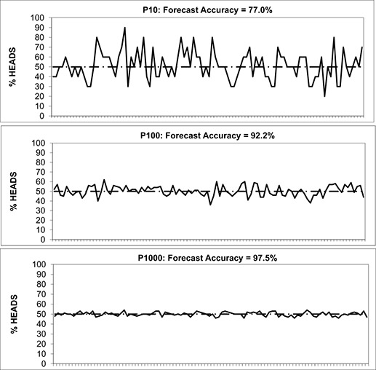
This isn't meant to be a trick question, and it doesn't take a doctorate in statistics to figure it out: The only rational forecast each day for each process is 50% heads. Exhibit 1.1 illustrates 100 daily trials of each of these processes. Since we are dealing with the independent tossing of fair coins, then, by definition, each process behaves according to the same underlying structure or rule—that over a large number of trials, each process will average about 50% heads. We fully understand the nature of each process, and we realize it makes no sense to forecast anything other than 50% heads each day for each process. However, as illustrated in the exhibit, the variation in the percentage of heads in each process is vastly different, as is the accuracy of our forecasts.
When there is a lot of randomness, or noise, in the behavior, we cannot expect to forecast it very accurately. Even when we know everything there is to know about the rules guiding the behavior, as we do here, the amount of randomness limits how accurate we can ever be. Also, in situations like these, any additional investment in the forecasting process would be a waste. There is nothing we could ever do to forecast P10 more accurately than P100, or P100 more accurately than P1000. The nature of each process, its underlying structure along with its random variability, determined the level of accuracy we were able to achieve.
Real life demand patterns are different from this in that the underlying mechanisms, knowable or unknowable, are not so simple as to be illustrated by independent tosses of a fair coin. Real life demand patterns may or may not have an underlying structure, we may or may not be able to discover and model that underlying structure, the underlying structure may or may not continue into the future, and there will be some degree of randomness.
What makes real life demand patterns so difficult to forecast is that the underlying mechanisms guiding their behavior may not be so apparent or may not even exist. Even if there is some structure to the historical pattern, it may not be obvious and can require good software or a skilled analyst to uncover it. But even then, even if we can discover and model the underlying behavior, there is no guarantee the behavior won't change over time. As forecasters, why do we even bother to try?
The coin tossing contest illustrates that there are limits to the forecast accuracy we can achieve. We can't assume that by applying more data, bigger computers, and more sophisticated software, or by exhorting our forecasters to work harder, we can always achieve the level of accuracy we desire. It is important to understand the limits of forecast accuracy, and to understand what level of accuracy is reasonable to expect for a given demand pattern. The danger is that if you do not know what accuracy is reasonable to expect, you can reward inferior performance, or you can waste resources pursuing unrealistic or impossible accuracy objectives. You can also miss opportunities for alternative (non-forecasting) solutions to your business problems.
^{[a]}The accuracies reported in this exhibit are based on 100 simulations of each process. The mathematical expectations of accuracy calculated using Blythe (1980, 2.2) are 75.4% (P10), 92.0% (P100), and 97.5% (P1000). (Colin Blythe, "Expected Absolute Error of the Usual Estimator of the Binomial Parameter." The American Statistician, August 1980, Vol. 34, No. 3, 155–157.)

